Lesson 03 – Purpose
At the end of this lesson, students will be able to:
- Formulate targeted interview questions based on a short case (qualitative research);
- Distinguish between open, closed, leading, and neutral questions;
- Conduct and observe a short interview with attention to neutrality and listening posture;
- Validate collected information by summarizing and feeding back;
- Reflect on their role as interviewer and formulate improvement points.

Lesson duration
135 minutes (2 hours and 15 minutes)

Roles:
Teacher: Owner of the pizza company (Bella Italia)
Students: Researchers who must analyze the problem

Preparation teacher
- Print Worksheet: Formulating Interview Questions
- Print Observation Form
- Print Reflection Sheet

Case Description: Bella Italia
Bella Italia wants to improve its information processes both internally and externally. The outdated (and on some part no functioning) website needs new functions added. In addition, the website must be linked in certain areas to existing systems (payments, kitchen management system, customer information system, etc.). We want to obtain a (1) prioritized list of requirements within the domain of ordering, preparing, and/or delivering. Before making the prioritized list of requirements we want you (2) to scope the process of ordering, preparing C assembling and/or delivery in a scope diagram.
(1) and (2) will be assembled on behalf of the interview(s) conducted by the teams.

Examples of scope diagrams:
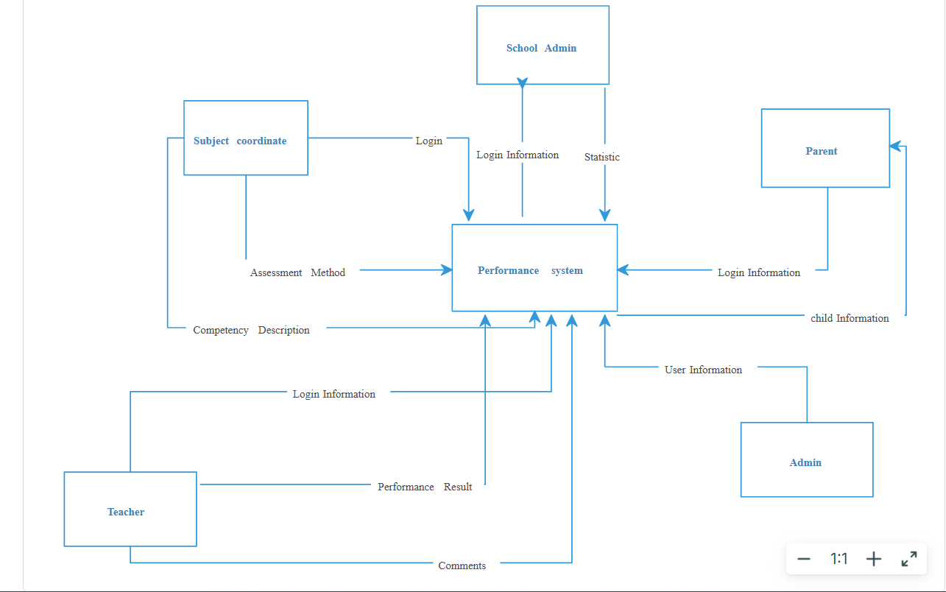

See: https://creately.com/diagram/example/ivlbg31u/scope-diagram-classic
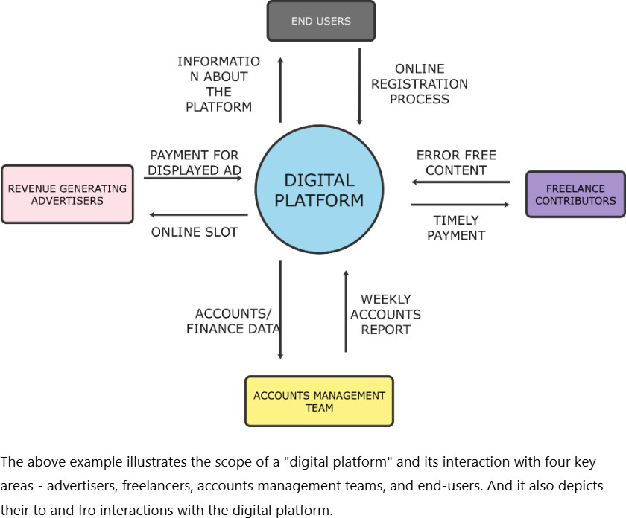

See: https://edrawmax.wondershare.com/flowchart/what-is-scope-diagram.html

Worksheet Formulating Interview Questions
Assignment:
Choose one process (ordering, preparation C order handling, delivery) and formulate 8 interview questions.
Use the table below to note your questions. Process name: Ordering
- What is the overall state of the Bella Italia pizzeria and what are the main problems? (introduction question)
- What features must be integrated into the website and what kind of payments must be included?
- Do you have any promotional deals or loyalty programs for the customers?
- How are orders processed for different ordering methods, such as phone orders and online orders?
- What are the main order values that must be stored in the system and later transferred into preparation management?
- When a customer has not paid in the past or is on your 'blacklist', how is that handled in your current ordering process?
- When you realize the original time estimate was wrong, what happens now and what problems does that cause in the ordering process?"
- How is the expected time until the order is ready currently determined and communicated to the customer for website, phone, and in-person orders?"

Reflection Sheet (Group)
What went well in our interview?
The communication between us and the client was quite difficult but he was very
nice and had patience with us and calmy answered every question we had for him.
Where did we lose my neutrality or focus?
We lost it when we had to talk about the diagram.
What would we do differently in the next interview?
Prepare more in advance.
What insights did we gain about the problems at Bella Italia? Process name: Ordering
- Ordering is fragmented across channels
Orders come in by in-person, phone, and website, but each channel works differently, causing inconsistency, errors, and extra workload for staff
- The website is unreliable and incomplete
The website is only partially working cannot fully support customers, forcing staff to compensate manually and reducing trust in online ordering
- Manual order handling is inefficient and error-prone
Orders are tracked using scattered notes and documents, making it easy to miss orders, lose information, or duplicate work
- Phone orders lack structure and validation
There is no automated blacklist/whitelist check and no reliable way to provide accurate time estimates, leading to poor customer communication and potential abuse
- There is no visibility into order status
Once an order is placed, there is no system to track cooking or delivery progress, which makes it hard to manage expectations and operations

- ETA accuracy is a major weakness
Cooking and delivery times are not calculated dynamically, resulting in unreliable estimates and customer dissatisfaction
- Lack of standardization increases staff workload
Different ordering methods require different handling, increasing training effort and making the process heavily dependent on individual staff members

Overall Insight
The ordering process at Bella Italia is manual, inconsistent, and not scalable. A unified, automated ordering system with standardized input, order tracking, and accurate ETA calculation is essential to improve efficiency, reduce errors, and enhance customer experience across all channels.

Marking:

When | Topic | Way to examine | Weight
Lesson-03 |  |  | 25%
 | Interview questions | At least 8 questions formulated?  Relevance ?  Neutral formulated? Leading to actionable insights? | 5%
 | What insights are collected on behalve of the interview? | Good and structured description of at least five insights derived from the interview undertaken. (1% per  insight). | 5%
 | Scope diagram. | Scope diagram makes sense due to the conducted interview (questions asked and answers given). 4% Scope diagram is  logical. 2% | 6%
 | Requirements specifications. | Specifications of five requirements (related to ordering, preparing or delivery, only one is allowed)of Bella Italia. The requirements a connected to the conducted interview  (1% per requirement). | 5%
 | Short presentation in Lesson-04 | 5 to 10 PPT slides about the group findings of:  - problems in the Bella Italia restaurant.  - requirements in the  Bella Italia restaurant | 4%

